The Tableau HR Scorecard: Measuring Success In Talent Management

# 1.INTRODUCTION

* 1. OVERVIEW:

The Tableau HR Scorecard is a framework designed to measure and evaluate the success of talent management strategies within an organization. It provides a way for HR professionals and business leaders to track and analyze key performance indicators (KPIs) related to workforce planning, recruitment, retention, and development.

* 1. PURPOSE:

The HR scorecard is a strategic HR measurement system that helps to measure, manage, and improve the strategic role of the HR department. The HR scorecard is meant to measure leading HR indicators of business performance. Leading indicators are measurements that predict future business growth. HR scorecard is a report that you conduct to calculate the success rate of human resource employees and the overall department. Any HR professionals looking to judge and assess thee business performance and productivity rate can start making use of this report to get valuable insights into the work progress.

# 2.PROBLEM STATEMENT AND DESIGN THINKING:

Problem Statement:

Problem Understanding, also known as Problem Definition or Problem Identification, is the initial and critical phase of any data analysis or problem-solving process. It involves gaining a clear and comprehensive understanding of the problem at hand, its context, scope, and objectives.

Design thinking:

Design thinking will help HR sit in the shoes of the employees, empathize, and see the world from their lenses. Through this process, they will architect the best possible employee experience. Many organizations in the contemporary world have re-written the norms of employee experience. This approach empowers HR managers to develop innovative solutions that prioritize the employee experience. By designing policies and programs tailored to employees and other stakeholders, HR can create a positive impact and drive meaningful changes.

### 2.1. EMPATHY MAP:

### 2.2. IDEATION AND BRAINSTORMING MAP:

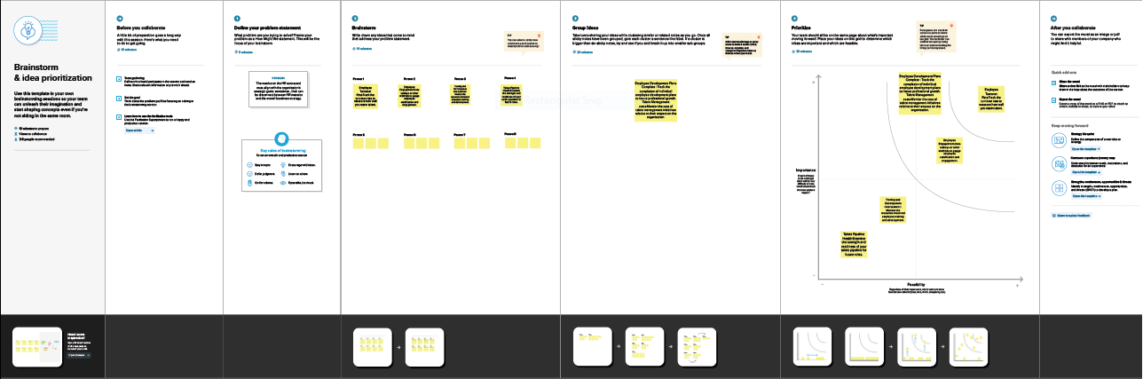

# 3.RESULT:

### DASHBOARD:

STORY:

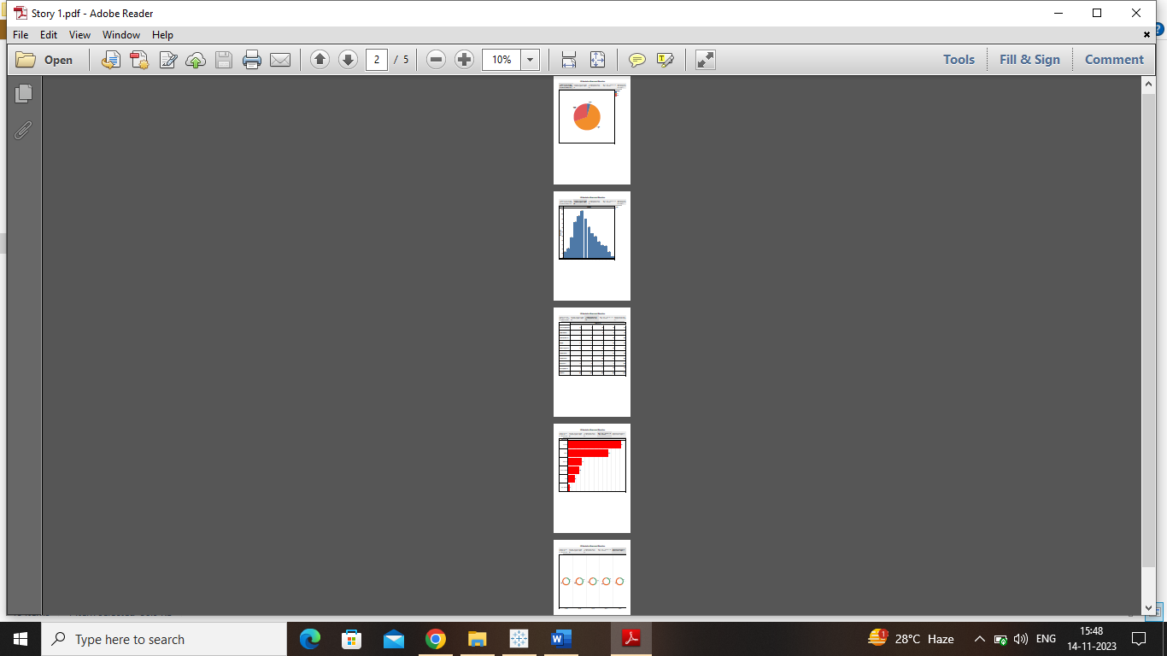

# 4.ADVANTAGES AND DISADVANTAGES :

|  |  |
| --- | --- |
| ADVANTAGES | DISADVAANTAGES |
| A scorecard helps keep the goals at the centre, uses specific parameters to track progress, and follows initiatives for monitoring actions. | Even though there are many HR scorecard templates you can use, the framework must be customized to suit your business requirements. This can be time-consuming and tedious – especially for first -time users. |
| The HR scorecard can come in handy for designing performance reports and dashboards, ensuring the focus remains on critical strategic issues and helping the HR department monitor the execution of its plan. | HR scorecard can be overly complicated to understand despite to understand despite there being many case studies and resources to read from. |
| Having a scorecard takes the guesswork out of trying to understand everyone’s responsibilities in the team and gets the entire department synced up under one structure. This also gives a much clearer picture of HR projects and initiatives. | HR scorecard usually required managers to report information, which can cause some resistance and even delays. |

# 5.APPLICATIONS:

The HR scorecard is a tool that helps measure, manage and improve the role of the HR function within an organization. HR metrics and KPIs or HR deliverables are measured using the HR scorecard. This data is also used to predict the potential growth of the organization.

# 6.CONCLUSION:

In the conclusion section of an HR management assignment, the main result is given. Hence it is necessary to be more specific than anything else. In the conclusion of HR management assignment, the final remedy or justification is usually given. The asked questions have some points and after implementing logic and theories to them the research outcome is detailed in the conclusion section. The conclusion should be very precise and in that section, the steps that can be taken by human resources development should be answered. Written a conclusion is a difficult task for many people because the logical deduction is needed in the segment.

# 7.FUTURE SCOPE:

An HR Scorecard is a tool that helps a company use its human resources strategically and prove how HR contributes to financial success. The scorecard measures HR deliverables, metrics, and KPIs that helps companies assess and foresee organizational growth and development.

The HR scorecard aligns the company’s strategies with efficient goal achievement metrics. It guides a company in optimizing its people for overall success by demonstration HR’s impact on the bottom line.

They are three ways to work the HR scorecards:

• It gauges HR’s role in creating value.

• It assesses key HR dimensions.

• It quantifies HR’s value and effectiveness.

HR scorecard help define and quantify the metrics that are used to set cost – cutting and value addition in an equilibrium.an anything else. In the conclusion of HR management assignment